Lab Task#6

Question#1

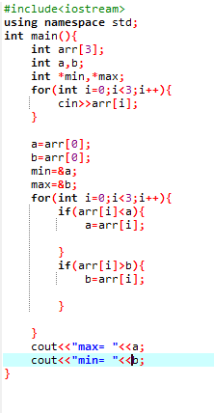

Output

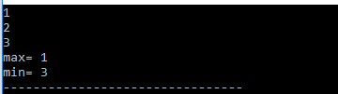

Question#4

Code;

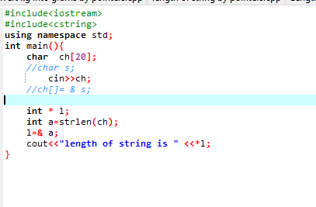

Output of Question #4



Question# 5

Code;

Output of Question# 5

